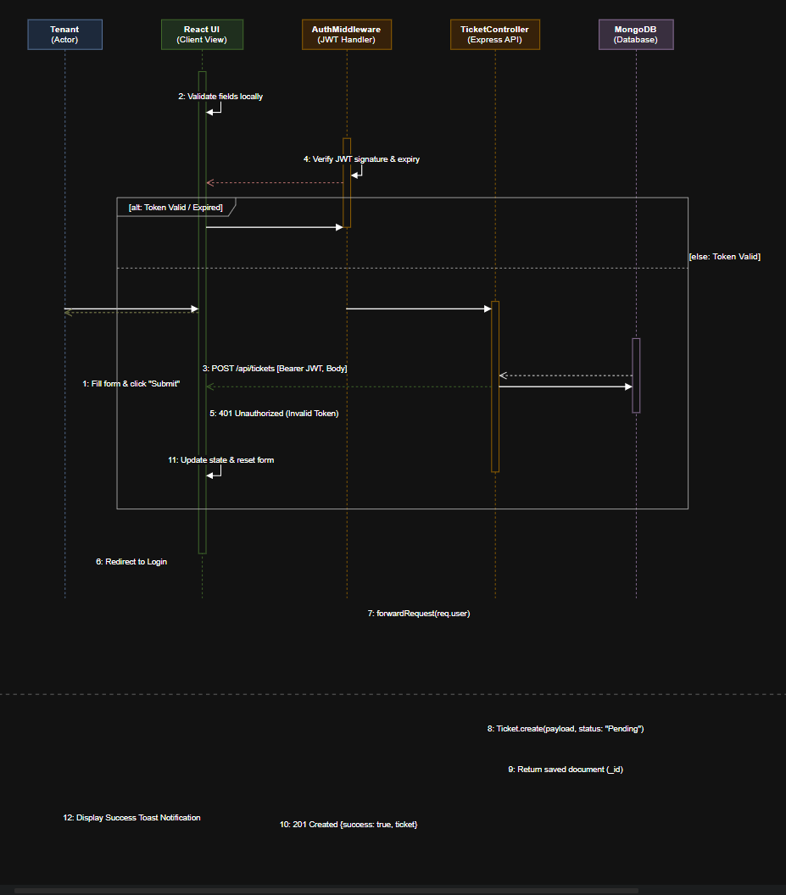
Sequence Diagram Specification: Maintenance Ticket Submission & Processing
Project Name: Apartment360 – Apartment Housing Management System
Mapped Use Case: UC-04 (Submit Maintenance Ticket) & UC-01 (JWT Authentication Verification)
Document Version: 1.0
1. Participant Lifeline Glossary
Lifeline | UML Stereotype | Role in Architecture
Tenant | Actor | The authenticated resident submitting the repair request.
React UI | Boundary / View | Client-side interface handling input capture, form validation, and state rendering.
AuthMiddleware | Control | Express middleware verifying JWT signature, expiry, and user role.
TicketController | Control | Express route controller executing business logic and data formatting.
MongoDB | Entity / Database | Persistent data store managing tickets and users collections.
2. UML Sequence Diagram (Mermaid)
Code snippet
sequenceDiagram
autonumber
actor Tenant as Tenant (Resident)
participant UI as React UI (Client)
participant Auth as AuthMiddleware (JWT)
participant Ctrl as TicketController (Express)
participant DB as MongoDB (Mongoose)

Tenant->>UI: Fill ticket form (Title, Category, Priority) & click "Submit"
activate UI
UI->>UI: Validate form fields locally (Non-empty checks)

UI->>Auth: POST /api/tickets [Headers: Bearer JWT, Body: TicketData]
activate Auth

Auth->>Auth: Verify JWT signature & expiration

alt Invalid / Expired Token
Auth-->>UI: 401 Unauthorized (Invalid Token)
UI-->>Tenant: Redirect to Login / Show session expired alert
else Valid Token
Auth->>Ctrl: forwardRequest(req.user {userId, role})
activate Ctrl
deactivate Auth

Ctrl->>DB: Ticket.create({tenantId, unitId, title, desc, priority, status: "Pending"})
activate DB
DB-->>Ctrl: Return saved ticket document (_id, createdAt)
deactivate DB

Ctrl-->>UI: 201 Created {success: true, ticket: newTicket}
deactivate Ctrl

UI->>UI: Append new ticket to state array & reset form
UI-->>Tenant: Display success toast notification ("Ticket #102 Created")
end
deactivate UI
3. Detailed Message Sequence Breakdown
- Step 1–2 (Client-Side Input & Validation): The tenant inputs the maintenance details on the React dashboard. The client validates that all required fields (title, description, priority) are populated before generating network traffic.
- Step 3–4 (Authorization Check): The client transmits an asynchronous HTTP POST request with the JSON payload and the stored JWT in the Authorization header. AuthMiddleware verifies the cryptographic signature of the token.
- Step 5–6 (Branching Logic):
  - Exception Flow (401): If the token is invalid or expired, the request is terminated immediately, returning an HTTP 401 Unauthorized status to prompt re-login.
  - Main Success Scenario: If valid, the user payload (userId, role) is appended to the request object and forwarded to TicketController.
- Step 7–8 (Persistence): TicketController invokes the Mongoose model method Ticket.create() to persist the record in the MongoDB cluster with a default status of "Pending".
- Step 9–11 (Response & State Update): The server sends a 201 Created response containing the complete ticket payload. React intercepts this response, prepends the new item to the active tickets state list, resets form inputs, and renders a visual confirmation banner to the tenant.

